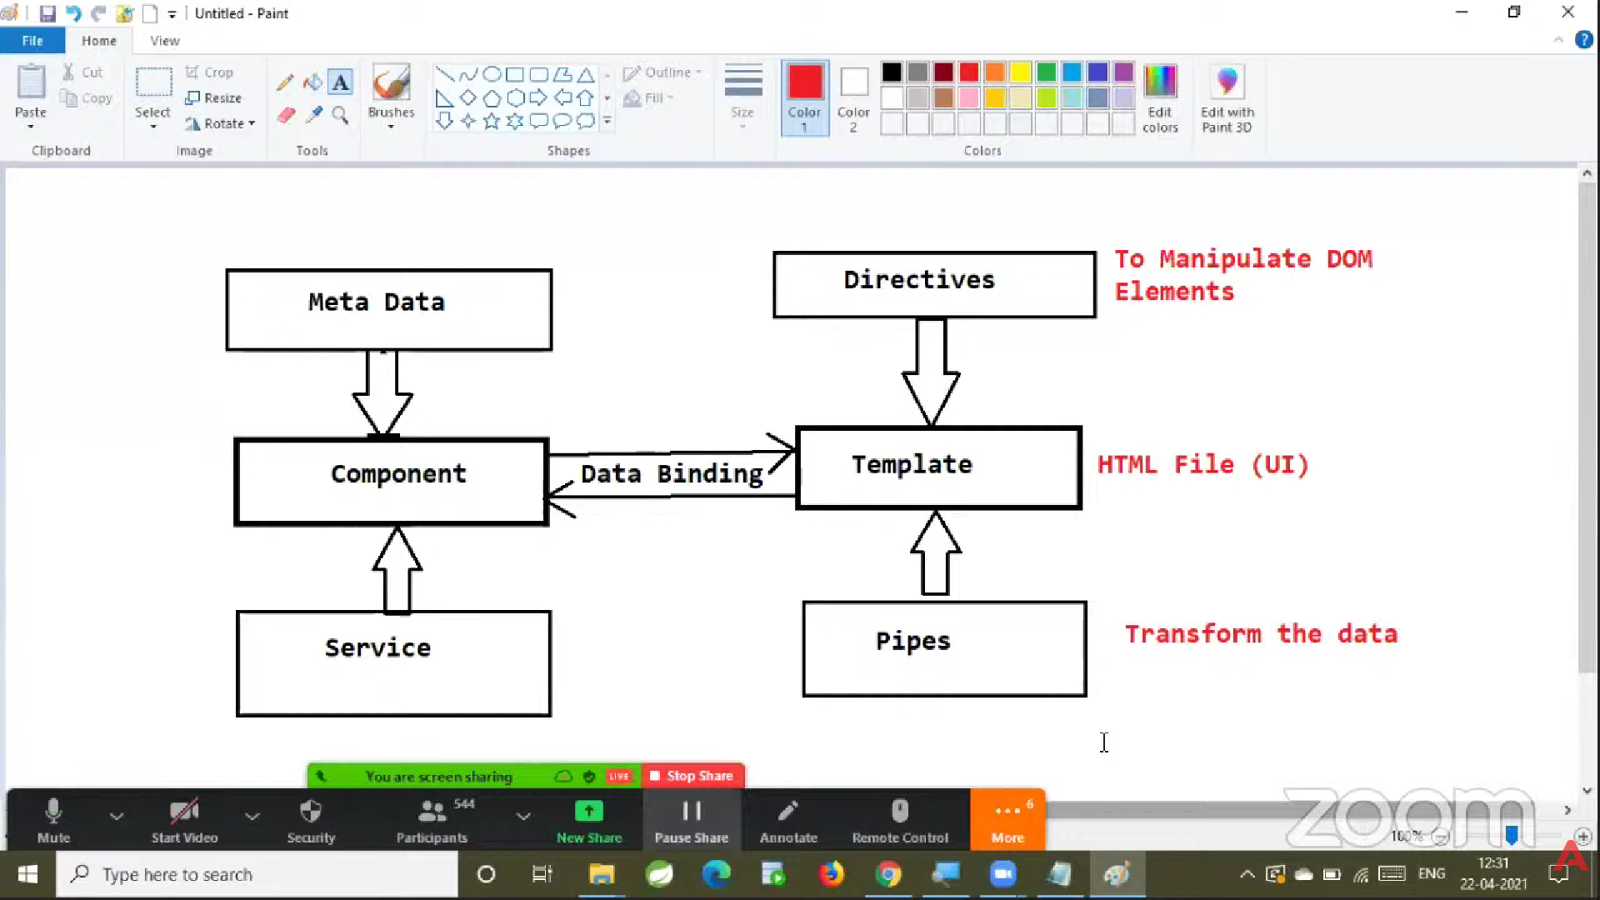

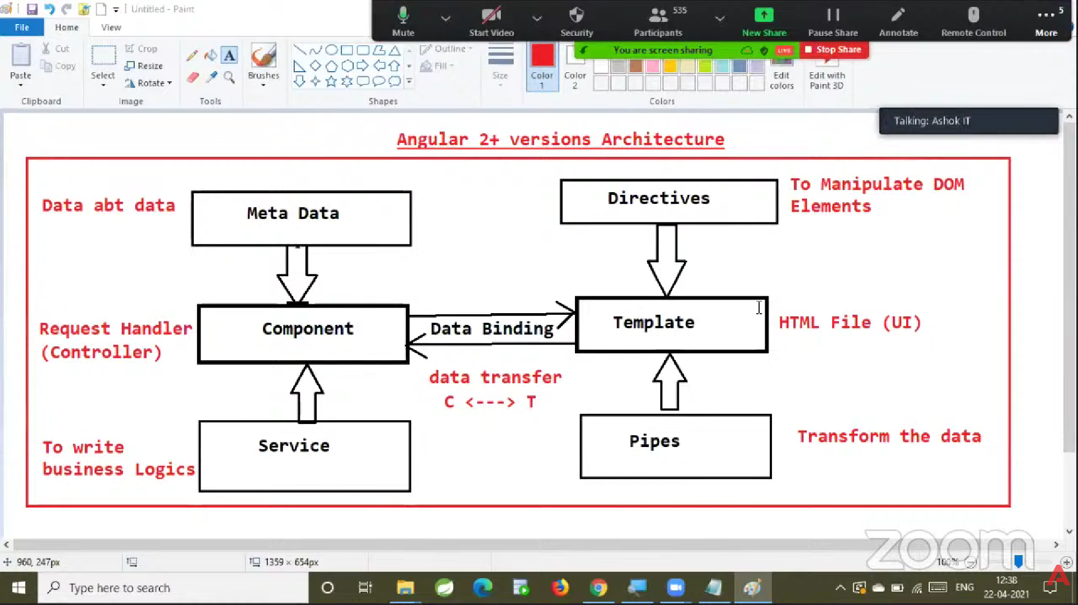
Sure! Let’s break this into two parts:
✅ Part 1: Full explanation of Angular Architecture
✅ Part 2: How it relates to Spring Boot MVC (so you can clearly connect Frontend vs Backend concepts)

✅ PART 1: Angular Architecture Explained
Angular is a frontend framework used to build Single Page Applications (SPA). Its architecture is based on key building blocks:

✅ 1) Component
- The heart of Angular.
- A TypeScript class that controls a part of the UI.
- Every screen/section (login, navbar, product list, etc.) is a component.
A component has 3 parts:
- TS → Logic (class)
- HTML → UI template
- CSS → Styling
📌 Role: Acts like a request handler for UI events (button click, form submit, etc.)
Example
@Component({
selector: 'app-user',
templateUrl: './user.component.html'
})
export class UserComponent {
title = "User Component";
}

✅ 2) Metadata
- Extra information given to Angular about a class.
- Provided using decorators like @Component, @NgModule.
📌 It tells Angular how to treat the class.
Example:
@Component({...})

✅ 3) Service
- A TypeScript class containing business logic.
- Used for:
✔ API calls
✔ Data processing
✔ Shared logic between components
📌 Promotes Separation of Concerns and Reusability.
Example:
@Injectable()
export class UserService {
getUsers() { ... }
}

✅ 4) Data Binding
How data flows between UI and Component.
Types:
- Interpolation: {{title}}
- Property Binding: [value]="name"
- Event Binding: (click)="save()"
- Two-Way Binding: [(ngModel)]="email"
📌 Connects UI ↔ Logic.

✅ 5) Template
- The HTML view for the component.
- Dynamic using Angular syntax.
Example:
<h1>{{title}}</h1>

✅ 6) Directives
Instructions to manipulate DOM.
Types:
- Structural: *ngIf, *ngFor
- Attribute: ngClass, ngStyle
Example:
<div *ngIf="isLoggedIn">Welcome!</div>

✅ 7) Pipes
- Format data in the template.
Example:
{{ today | date }}
{{ price | currency:'INR' }}

✅ Angular Request Flow (Simplified)
User Event → Component → Service → API → Response → Update UI

✅ PART 2: Relating Angular Architecture to Spring Boot MVC
Let’s map Angular to Spring Boot MVC side-by-side:
Angular | Role | Spring Boot MVC Equivalent
Component | Handles UI events | Controller
Service | Business logic (UI-side) | Service Layer
Template (HTML) | View | JSP/Thymeleaf View
Model (TS properties) | Holds data for UI | Model/DTO
HttpClient | Calls backend APIs | RestTemplate/WebClient
Module | Application structure | Packages/Configurations
Routing | Navigates between pages | URL Routing via Controllers

✅ Detailed Mapping
✅ 1️⃣ Component ↔ Controller
- Angular Component handles UI actions like button clicks.
- Spring Controller handles HTTP requests like GET/POST.
Angular Component
saveUser() {
this.userService.addUser();
}
Spring Controller
@PostMapping("/user")
public User addUser() { ... }

✅ 2️⃣ Service ↔ Service Layer
- Angular Service calls backend APIs and contains UI-side logic.
- Spring Service contains server-side business logic.

✅ 3️⃣ Template ↔ View
- Angular HTML template = UI.
- Spring Boot (MVC) uses Thymeleaf/JSP if server-side rendering.
- In REST APIs, JSON replaces UI views.

✅ 4️⃣ Model ↔ Entity/DTO
- Angular stores data in variables.
- Spring stores data in DTOs/Entities.

✅ 5️⃣ API Communication
- Angular uses HttpClient to call Spring Boot REST Controllers.
- Spring Boot returns JSON responses.
Flow:
Angular Component → Angular Service → HTTP → Spring Controller → Service → DB

✅ Combined Architecture View
⭐ Frontend (Angular SPA)
- Handles UI, validation, routing, display
⭐ Backend (Spring Boot REST)
- Handles business logic, data processing, database access
User
↓
Angular Component
↓
Angular Service
↓ (HTTP)
Spring REST Controller
↓
Spring Service
↓
Repository / Database

✅ In Simple Words
- Angular = Client-side MVC
- Spring Boot = Server-side MVC
Angular focuses on UI & UX.
Spring Boot focuses on APIs, Logic & Database.
They complement each other perfectly.

✅ Want Next?
I can provide:
✅ A real working example: Angular calling Spring Boot
✅ Code for both sides
✅ Interview-style explanation
Just say "Yes, show example."

